Forecasting of Global Price of APSP Crude Oil
Rohit Bhargav Peesa, Anuradha Chaubey, Pranay Madhav Vankadari, Saisha Hemrajani

Abstract— Being an essential component in transportation, every industry is either directly or indirectly dependent on Crude Oil. The review deals with application of drift, ETS and ARIMA models to forecast global price of Crude oil using time series analysis techniques. We also propose that, despite, simplest drift model outperforming advanced models such as ETS and ARIMA for predicting price of Crude Oil fails in residual diagnostics. We use APSP variant for this analysis and conclude ARIMA performs best.

Keywords- ARIMA, Forecasting, Crude Oil, Price, ETS, Drift
- INTRODUCTION
This paper deals with a work on forecasting Crude oil price of APSP crude oil variant. APSP is expanded as average petroleum spot price which is derived from equally weighing Brent, WTI and Dubai variants of crude oil.
Crude oil as a commodity has always been in demand for years. Many research outcomes say that crude oil price's labile nature has the capacity to reflect market variations and is regarded as market decider. Moreover, being the most internationally traded product, crude oil prices are also considered as benchmark in global trade market. Any pandemic, international political issues, natural disaster, or war situations, immediate impact is witnessed first with crude oil prices and demand variation. In recent times, Russia - Ukraine war has also showed a huge impact on crude oil prices as Russia is one of the major producers of crude oil. Forecasting such a volatile commodity is an arduous task [5].
In general, most of time series models and econometric models use ARIMA and exponential smoothing models as they have been proved to produce better results, but this analysis performs best with drift model. Our evaluation panel consisted of four metrics: Root Mean Squared Error (RMSE), Mean Absolute Error (MAE), Mean Percentage Error (MAPE) and Mean Absolute Scaled Error (MASE).
The rest of the paper is organized as section II which involves description of data, techniques, their implementation, and results. Followed by section III where the results and evaluation of forecasts in explained. Lastly, Section IV where we conclude our inference.

- DATA PREPROCESSING
Data split into 80-20 ratio used to train and test the model has been acquired from FRED economic data website. Values in data represent the benchmark prices of crude oil in global market determined by largest exporter. As its monthly data, prices of the month are averaged in US dollars [3]. The dataset contains prices from 1990 January to 2022 April.
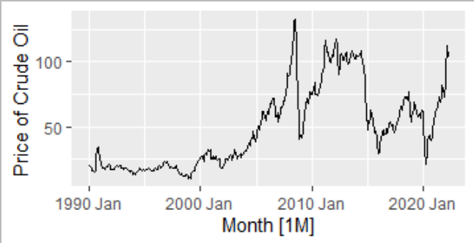
Fig 1. Average Petroleum Spot Price of Crude Oil
Fig 1. shows variation in price of crude oil over the period from 1990 Jan to 2022 April. An increasing trend with a unnoticeable seasonality is inferred by looking at the above graph. Let’s confirm our inference using most robust STL decomposition technique.
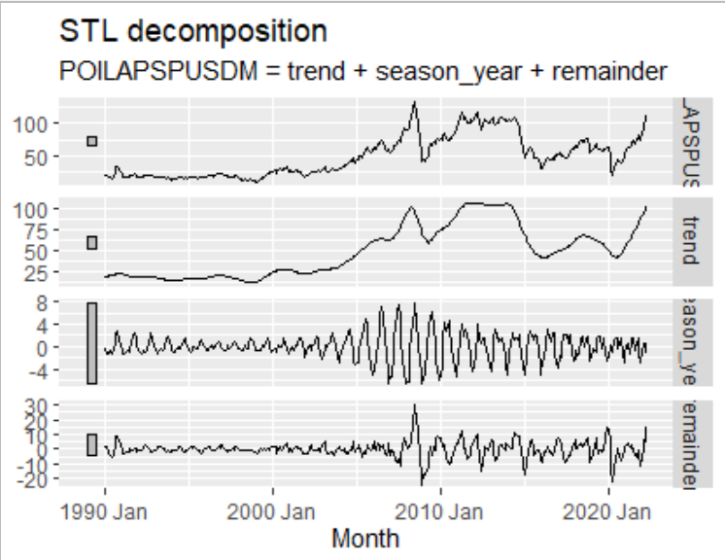
Fig 2. STL decomposition of plot
Our inference has been proved right as decomposition also shows an increasing trend with a seasonality which keeps varying. Exponential increase followed by variation by series of increase and decrease depicts that a mathematical transformation is needed to adjust it. We apply boxcox transformation to adjust it. Figure below shows the transformed price.
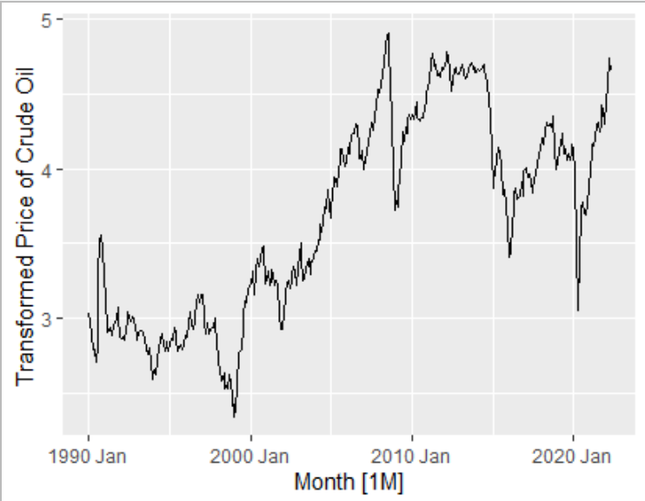
Fig 3. Transformed Price
This transformed data is now split into training and testing set where we holdout 20% of the sample for test. Train data consists of observations from 1990 January to 2015 October and test contains observations from 2015 November to 2022 April.
- METHODOLOGY AND RESULTS

- Drift
Firstly, we apply an extremely simple method called a drift which is one of the benchmark methods considered to be effective. It is a type of naïve method which considers variations in forecasts over time as average change based on previous data, that change over time is known as drift. The plot below shows the forecast using drift method. It clearly considered the overall increasing trend and tries to forecast it.
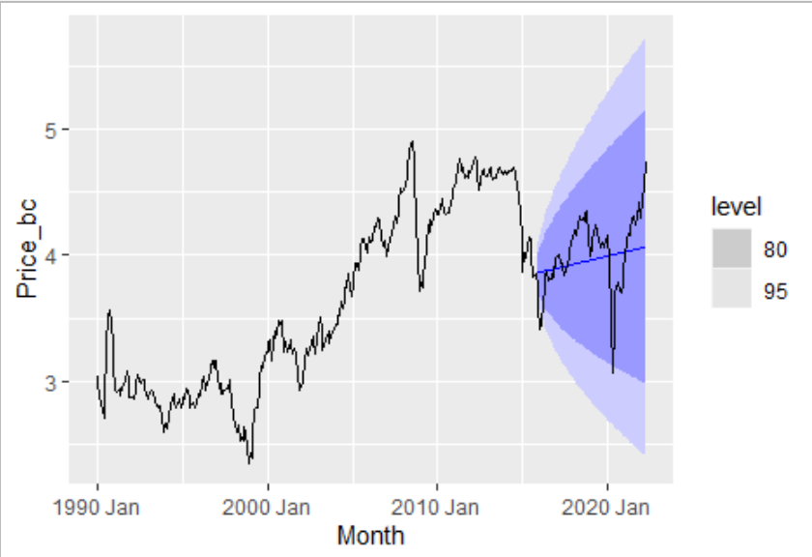
Fig 4. Forecast with drift model

- ETS
Secondly, we apply a variant of exponential smoothing model denoted as simple exponential smoothing method. Exponential smoothing methods make forecasts by weighing previous observations. They assign weights which decay exponential with increase in age of observation. Researchers say this model is reliable as it gives more weightage to the observation which is recent.
We have preferred using simple exponential method as it a method which is applied when there is no clear seasonality or trend. Our time series plot doesn’t show any clear seasonality and has lower gamma. This method assumes that most recent observation is most important, and weight is assigned only to that because of which this model seems to be failing. Impact, of lower value of alpha is clearly indicated by a smooth forecast.
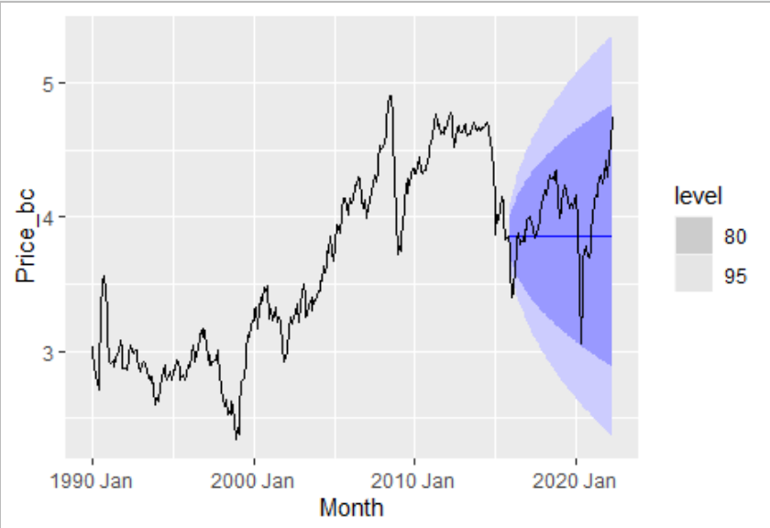
Fig 5. Forecast with ETS model
- ARIMA
Finally, autoregressive integrated moving average (ARIMA) model is implemented. It is a model which focuses on autocorrelations in data unlike ETS which focuses on only trend or seasonality.
Stationary tests help understand that our time series is not constant over time which makes the distributions and forecasts tough to predict or predicts turn out to be inaccurate when predicting long term period like 7 years as in this analysis. So, we apply 1 normal differencing to make it stationary.
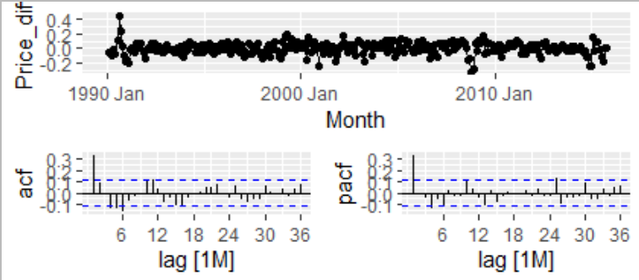
Fig 6. ACF and PACF after differencing

ARIMA model has two parts (p,d,q) for nonseasonal aspect and (P,D,Q) for seasonal aspect. As the plot does not show any seasonality P=D=Q=0. We have taken 1 differencing so d=1. In PACF plot we notice that after lag 1, most significant nonseasonal lag is at lag 25 which appears confusing so when model selection is automated it was found that ARIMA (3,1,3) was best. Forecast for test data using ARIMA (3,1,3) is shown in Fig 7.
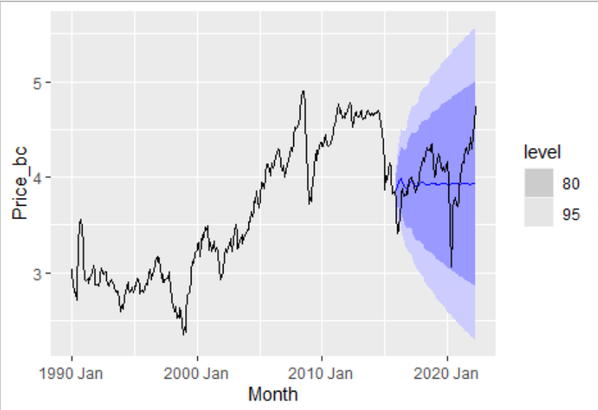
Fig 7. Forecast with ARIMA model

- MODEL COMPARISON AND EVALUATION

- Forecast Comparison
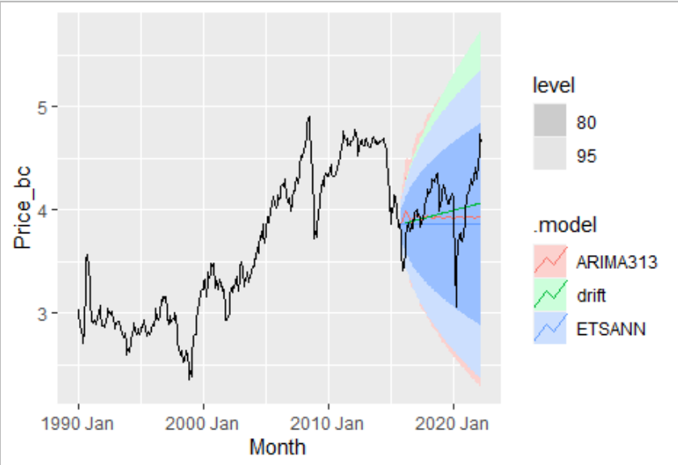
Fig 8. Forecast comparison
In section III, the forecasts for each model have been illustrated, here we compare them. Fig 8. ARIMA has a bigger prediction interval while ETS smallest prediction interval. ETS model does not display any clear trend or seasonality in forecast and all the forecasts are same value, drift method shows an increasing trend without seasonality and ARIMA shows minute variations.
- Model Evaluation

- Point Forecast Accuracy Metrics
The data was split in ratio 80% : 20% for train and test sets. The train data set was used to train the model using various forecasting techniques whereas the test set was used to check the model accuracy for each technique.

Model | RMSE | MAE | MAPE | MASE
ANN | 0.335 | 0.275 | 6.73 | 1.11
Drift | 0.276 | 0.216 | 5.43 | 0.869
ARIMA(3,1,3) | 0.307 | 0.245 | 6.08 | 0.985
Table 1. Model performance on test set
The above table clearly help us infer that Drift method excels in forecasting crude oil price, irrespective of the accuracy metric we choose to compare.
- Residual Diagnostics
Residual diagnostics must be done as it helps check if model makes use of all the information from data. The residuals of model must resemble white noise, be uncorrelated and have zero mean.
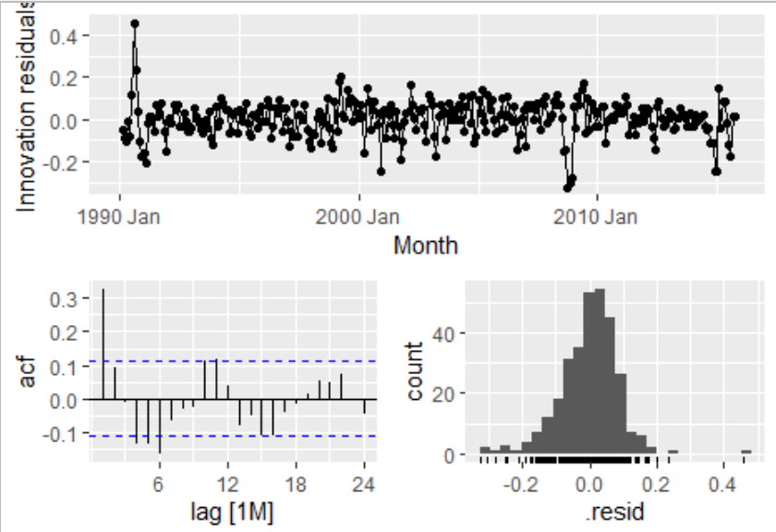
Fig 9. Residual diagnostics of drift model
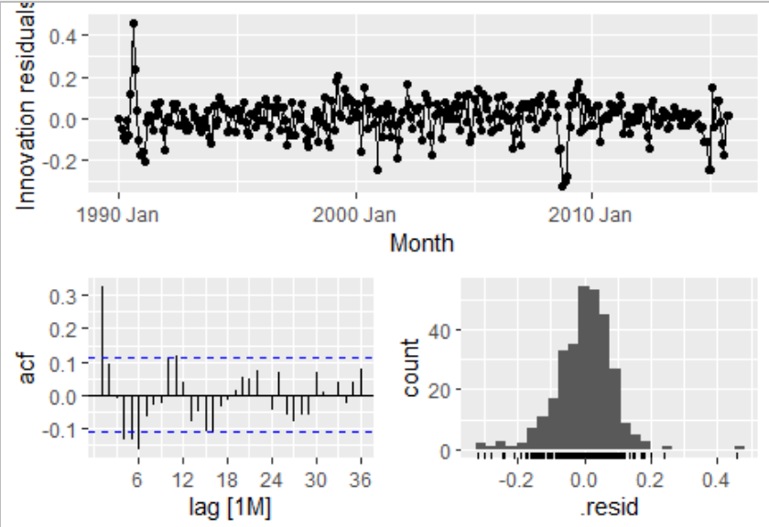
Fig 10. Residual diagnostics of ETS model
The above plots show residual diagnostics of drift and ETS models. The residuals appear to be white noise but in Ljung-Box test p value less than 0.05 which says residuals don’t obey principles of white noise and both drift and ETS methods lead to models who residuals don’t make use of all the information available.
The graphs below belong to ARIMA model whose graphs as well illustrate that residuals are white noise which is also backed up with Table 2. showing evidence of Ljung-box test where p-value is way above 0.05 denoting that residuals make use all the key information present in data.
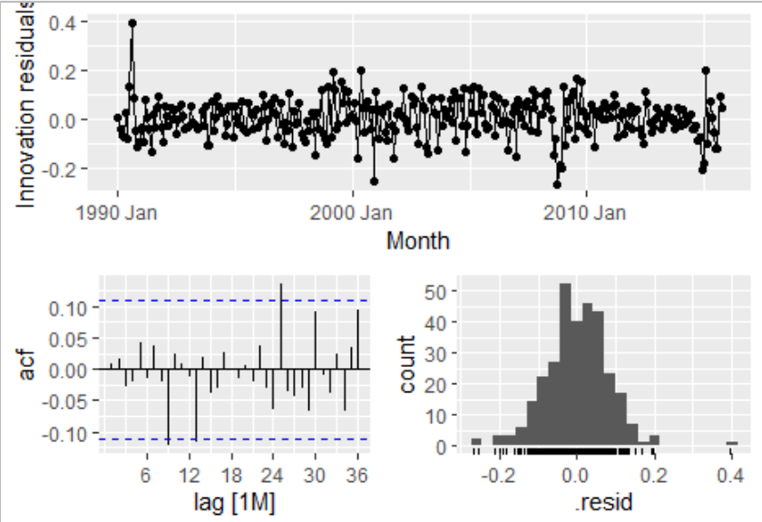
Fig 11. Residual diagnostics of ARIMA model
Model | P value
ARIMA | 0.343
ETS | 4.95e-10
Drift | 14.5e-10
Table 2. Ljung box test for models
- Distribution Forecast Accuracy
Since both residual diagnostics and point forecast accuracy have given slightly contradicting results let’s check the accuracy of distributional forecasts. Distributional forecasts represent the probable region where the forecast may lie and point forecasts are mean of these which the model considers most possible. In most cases, for long term predictions point forecasts go wrong which is when distributional forecasts help us so checking accuracy of them as well is must. The accuracy of distributional forecasts has been done using scale free Continuous Ranked Probability Score which calculates weighted absolute error for whole distributional region based on probabilities. Scale free makes comparison amongst different models easier.
Model | Skill Score
ARIMA(3,1,3) | 0.0895
Drift | 0.152
Table 3. Distributional Forecasts Accuracy
Table 3. illustrates that drift performs better than ARIMA. For long term predictions as here, focusing on distributional forecast is better than focusing on point forecasts as prediction intervals size increases with duration.
IV. CONCLUSION
In this paper, using FRED data from 1990 to 2022 and applying drift, ARIMA and simple exponential smoothing models, we have forecasted global price of APSP variant of Crude oil. Drift model is great in predicting price and outperforms other complex and traditional models based on RMSE, MAE, MASE and MAPE accuracy metrics but is fails with residual diagnostics. Even though, accuracy metrics of ARIMA are bad, applying ARIMA would be a good choice as we must not solely focus on accuracy metrics in a time series which is volatile. Also, difference in accuracy metrics of both is not much; distribution forecasts accuracy must be focused for long term predictions which suggests ARIMA. Moreover, a model considering every data point available is important in volatile business.

REFERENCES
- Z. Mo and H. Tao, "A Model of Oil Price Forecasting Based on Autoregressive and Moving Average," 2016 International Conference on Robots & Intelligent System (ICRIS), 2016, pp. 22-25, doi: 10.1109/ICRIS.2016.4.
- K. Kanchymalay, R. Sallehuddin, N. Salim and U. R. Hashim, "Time series based forecasting for crude palm oil price utilizing neural network algorithms," 2017 6th ICT International Student Project Conference (ICT-ISPC), 2017, pp. 1-4, doi: 10.1109/ICT-ISPC.2017.8075334.
- International Monetary Fund, Global price of APSP crude oil [POILAPSPUSDM], retrieved from FRED, Federal Reserve Bank of St. Louis; https://fred.stlouisfed.org/series/POILAPSPUSDM, June 3, 2022.
- A. Alizadeh and K. Mafinezhad, "Monthly Brent oil price forecasting using artificial neural networks and a crisis index," 2010 International Conference on Electronics and Information Engineering, 2010, pp. V2-465-V2-468, doi: 10.1109/ICEIE.2010.5559818.
- C. W. Yang, M. J. Hwang, and B.N. Huang, “An analysis of factors affecting price volatility of the US oil market,” Energy economics, vol. 24, pp. 107-119, 2002.
- E. Antwi, E. N. Gyamfi, K. A. Kyei, R. Gill and A. M. Adam, "Modeling and Forecasting Commodity Futures Prices: Decomposition Approach," in IEEE Access, vol. 10, pp. 27484-27503, 2022, doi: 10.1109/ACCESS.2022.3152694.
- Hyndman, R.J., & Athanasopoulos, G. (2013). Forecasting: principles and practice.

APPENDIX
- No/ very low Seasonality is inferred from the ACF plot below and strengths after decomposition.

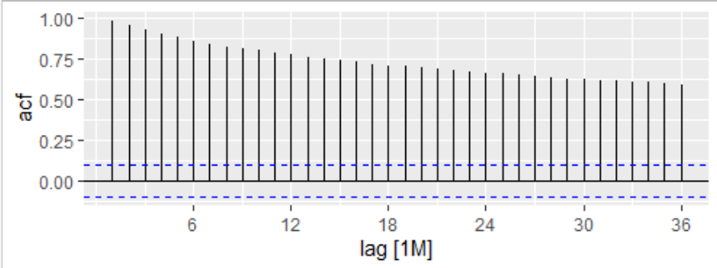
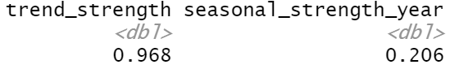
- Proof of non-stationarity and no of times differencing is needed.
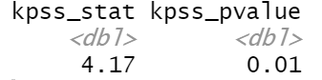
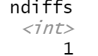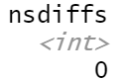
- AICc values of model.
